Project Deliverable 2
Amin Majdi
The autonomy in this project can be categorized as Sense-Plan-Act.
- Autonomy explanation:
  - The bell rings, and the robot goes to the door:
    - In this task, the robot has level 10 autonomy as it goes to the door to get some information without permission.
  - Recognizing the person at the door:
    - There are two different situations in this task. If the person is Known, the robot will open the door and then searches for the person to let him/her know somebody is coming. Therefore, the robot has level 9 autonomy in this task.
    - If the person is unknown, the robot has level 5 autonomy for executing the task. The robot will need human permission to open the door to an unknown person.
  - Opening the door:
    - The robot is fully autonomous. There is no need for human action at this level after getting permission.

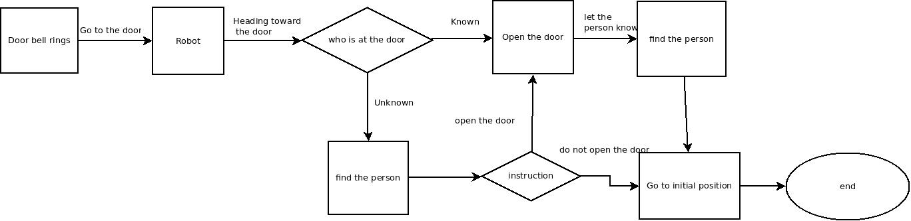

Flowchart decomposition:
Doorbell rings:
The doorbell will communicate with the robot through a Ros topic in this stage. After receiving the message from the doorbell, the robot departs to the door to get some information.
The robot goes to the door-phone
In this task, the robot knows precisely the map of the apartment and the location at which it is. This is a perception task as the robot needs to monitor all the objects around and move toward the door. The robot will do this task using depth cameras, which can help it know its location with respect to all objects around.
Recognizing the person at the door
In reality, the robot will do that using computer vision. It will analyze the door-phone screen to recognize the person at the door and find whether it knows the person or not, using its database. In this project, as the robot reaches the door, it will request a service. The ROS service will provide information about the person at the door.
Find the person
This task is also a computer vision mission. The robot needs to go to all the rooms and search for the person using its cameras. After finding the person, the robot will go near the person (Ideally stops at 1 meter distance), and the person will see the instruction on the robot's screen. If the robot asks the person about opening the door, in reality, the person can touch the screen to select the commend. The robot either goes to open the door or goes to its home position based on the command. All the communications between the robot and the person in this project will happen through ROS topics.
Opening the door
When the robot is at the door, it can approach the handle and use its gripper to open the door. To do so, the robot needs to see the door handle using its cameras. In this project, this step also happens through ROS topics.
Go to the initial position
The robot knows about its location at the moment. So this ask is the same as going to the door. The robot will find its way to go to its initial position.

